Iaas-Intel Provisioning
This document describes the Tidal workflow for Intel-IaaS server provisioning. Server provisioning is a complex set of processes that occur within Tidal against a data center virtual infrastructure to provide one or more servers running Microsoft Windows or Linux.

IaaS-Intel Provisioning Architecture

The Server Provisioning System interacts with the Enterprise Service Bus (ESB) to communicate with external entities which could the Enterprise Cloud portal. The provisioning workflow executes on the Tidal Enterprise Orchestrator (TEO). Service Requests from the Enterprise Cloud Portal are passed to the TEO engine along with service data to trigger workflows to perform the necessary actions.
From a high level perspective, interactions occur among the following components:
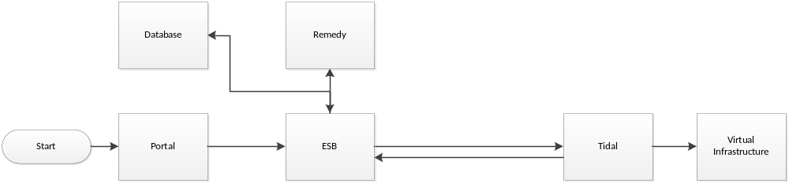
- Customer initiates an Intel-IaaS server provisioning request through the portal.
- Prior to sending the request to Tidal, the portal sends a request to open a Remedy ticket.
- Upon successfully receiving a remedy ticket, the portal sends the request to the enterprise service bus (ESB).
- The ESB routes the request to the appropriate Tidal infrastructure in the correct datacenter .
- The appropriate Tidal workflows fulfill the provisioning request using virtual infrastructure at that data center.
- During the provisioning, updates are sent to endpoints on the ESB that updates status in both Remedy and the service item database which is read by the portal.

Tidal IaaS-Intel Workflow

This section describes the IaaS-Intel workflow process for all lifecycle management operations of an Intel-Intel service item.

Overview

The AEC VM Provisioning Handler process determines which operation to perform and branches out accordingly based on the appropriate action. The workflows are executed based on the data provided to the workflow to accomplish the requested task. If there are no failures these processes, a complete provisioning status is reported back to ESB.
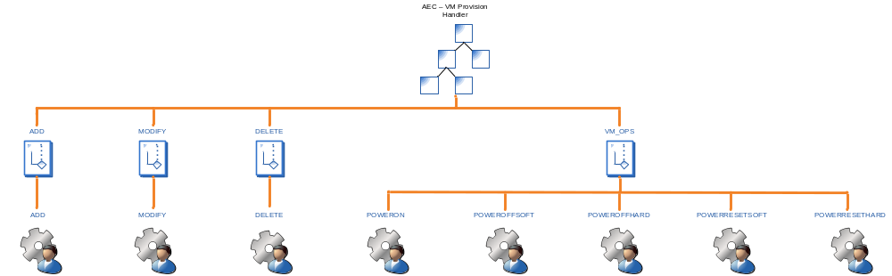
Server Provisioning Workflow Top Level
The WSDL comprises all Tidal workflows that are published on that server. The following are the locations where the WSDL can be located.
Environment | WSDL | Method
Development | http://10.71.0.73:61527/ws/process?wsdl  http://10.71.0.74:61527/ws/process?wsdl | StartAECVMProvisioningHandler
UAT

SIT

Production

Note that the payload isn’t validated nor will you receive any elements indicating what should be passed. Until a solution is determined, this document will provide the requirements for what is sent to the server.
For example: Take the following for the required method:
<soapenv:Envelope xmlns:soapenv="http://schemas.xmlsoap.org/soap/envelope/" xmlns:tem="http://tempuri.org/">
<soapenv:Header/>
<soapenv:Body>
<tem:StartAECVMProvisioningHandler>
<!--Optional:-->
<tem:targetOverride>?</tem:targetOverride>
<!--Optional:-->
<tem:ServiceRequestXML>?</tem:ServiceRequestXML>
</tem:StartAECVMProvisioningHandler>
</soapenv:Body>
</soapenv:Envelope>

In the usage examples below, the CDATA data would go into the above ServiceRequestXML element.

Usage
The following table provides information in regards to the elements required for the process to be used.
Element | Usage
action | One of the following values  - ADD – Create a new Virtual Server. This uses the ADD action path of the “AEC - VM Provisioning Handler”. At the end of the path a change request “Add Virtual Server %VMNAME%” class 1000 is created.  - VM_OPS – An operation to be performed on an existing Virtual Server. This uses the VM_OPS action path of the “AEC - VM Provisioning Handler”. At the end of the path a change request %SUBJECT% %VMNAME% class 1004 is created. Refer to Subject element to perform the following operations to an already provisioned device.  - MODIFY – Change CPU, Memory or Both. This Uses the MODIFY action path of the “AEC - VM Provisioning Handler”. At the end of the path a change request “Modify Virtual Server %VMNAM%” class 1003 is created.  - DELETE – DE provision a Virtual Server. This uses the DELETE action path of the “AEC - VM Provisioning Handler”. At the end of the path a change request “Delete Virtual Server %VMNAME%“ class 1002 is created.
subject | This element is only required if the action is VM_OPTS and specifies one or more lifecycle action on the device.  - POWERON – Used to power on a VM. This creates the change request “POWERON - %VMNAME%” class 1004.  - POWEROFFSOFT– Used to power off a VM with a guest OS shutdown first. This creates the change request “POWEROFFSOFT - %VMNAME%” class 1004.  - POWEROFFHARD– Used to hard power off a VM. This creates the change request “POWEROFFHARD - %VMNAME%” class 1004.  - POWERRESETSOFT – Used to power cycle a VM with a guest OS shutdown first. This creates the change request “POWERRESETSOFT - %VMNAME%” class 1004.  - POWERRESETHARD – Used to hard power cycle a VM. This creates the change request “POWERRESETHARD - %VMNAME%” class 1004.
vmname | The name of the VM. This will be the Vcenter name of the Virtual Machine and the Guest host name.
company | The name of the company. This will be the company folder used in Vcenter under the Customer VMs folder. The customer vm folder will be created in the customer onboarding process, which is out of scope for this section.
osType | Platform for the operating system.  Expected Values are one of the following:  - Windows  - Linux
templateFolder | The path in Vcenter to the folder containing the Template.  Expected values:  VM data center/folder/folder/folder  Note: The complete path from the data center and all logical folders up to where the vm/template exists must be provided.
template | The name of the vm/template to clone.
dataStore | The data store in Vcenter the virtual machine will be created in.  Expected value:  VM data center/folder/folder/datastore  Note: The complete path from the data center and all logical folders up to and including the datastore must be provided.
cpuCount | The number of virtual CPUs.  Expected values:  Numeric value
memory | The memory size in MB.  Expected values:  Numeric value
portGroup | The Vcenter network portgroup.  Expected values:  VM data center/folder/virtual distributed switch/portgroup
osVersion | The Full version of the OS.  Expected values:  - Windows Server 2003 32 bit  - Windows Server 2003 64 bit  - Windows Server 2008 32 bit  - Windows Server 2008 64 bit  - Windows Server 2008 R2 64 bit
adminPassword | The password for the administrator or root user of the guest OS.  Expected Value:  Text

Error Handling
This section will describe how errors are handled and communicated to other service components in the solution.

Error Recovery
This section will describe how errors are recovered relative to the provisioning component.

ADD
When the ADD action is passed, the following processes occur, as illustrated below:
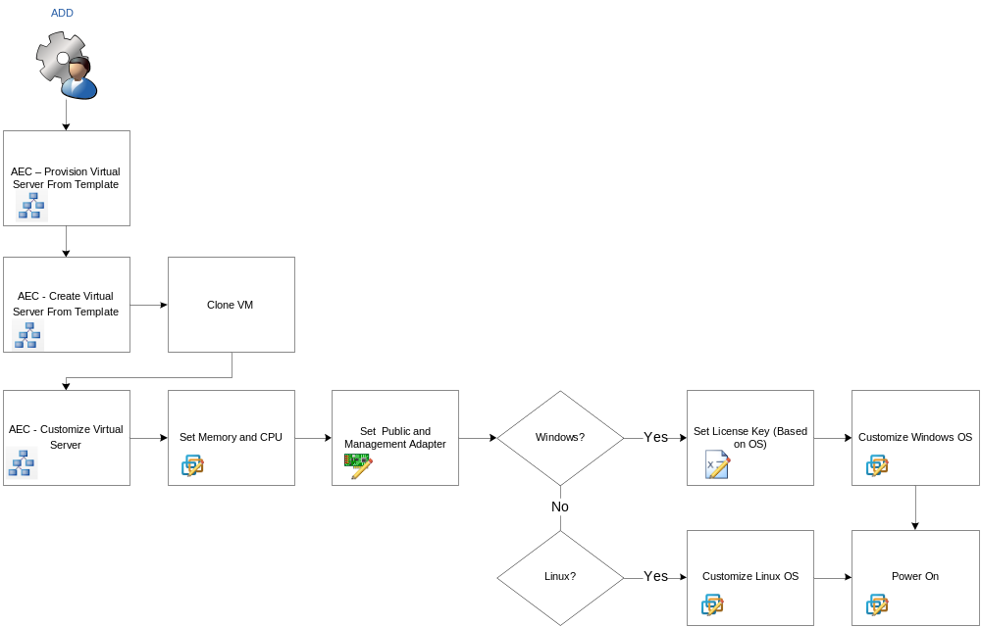
Add Server Process
The following processes occur during the add server process:
- A clone of the VM or template occurs.
- The memory and CPU is configured.
- The public and management adapter is set to the appropriate portgroup.
- If Windows, the appropriate license key is set and the customize process (SYSPREP) occurs.
- If Linux, the customize Linux process occurs.
- The VM is powered on at completion.
Example Usage:
Action | Required Values | Sample
ADD | <action>  <subject>  <vmName>  <company>  <osType>  <templateFolder>  <template>  <dataStore>  <cpuCount>  <memory>  <portGroup>  <osVersion>  <admininPassword> | <![CDATA[  <vm>  <action>ADD</action>  <vmName>DEV-MS100</vmName>  <company>Test</company>  <osType>Windows</osType>  <templateFolder>dal-dev/Management/Templates/Cloud/2008</templateFolder>  <template>V-T-WIN2K8ENT-R2SP2-64</template>  <companyFolder>dal-dev/Customer Vms/Test</companyFolder>  <dataStore>dal-dev/NFS_DEVNTAP_DS1</dataStore>  <cpuCount>2</cpuCount>  <memory>2048</memory>  <portGroup>dal-dev/aecdevvs01/aecdevvs01/dvpg_0220_ACS</portGroup>  <osVersion>Windows Server 2008 R2 64 bit</osVersion>  <adminPassword>Aeccloud123</adminPassword>  </vm>  ]]>

MODIFY
When the MODIFY action is passed, the following processors occur, as illustrated below:
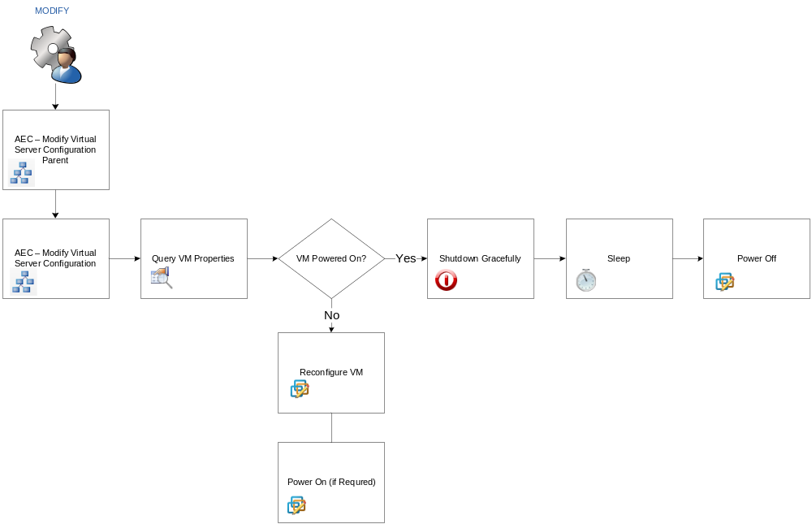
Modify Server Process
The following processes occur during the modify server process:
- The VM is queried for current properties.
- If the VM is powered on, a graceful shutdown occurs. If it does not shut down in a specified period of time, the VM is powered off forcefully.
- The VM is reconfigured with the appropriate memory and CPU settings.
- The VM is powered on if it is required.
Example Usage:
Action | Required Values | Sample
MODIFY  (note: Requires a reboot of Virtual Server) | <action>  <vmName>  <company>  <cpuCount>  <memory> | <![CDATA[  <vm>  <action>MODIFY</action>  <vmName>DEV-MS101</vmName>  <company>Test</company>  <cpuCount>2</cpuCount>  <memory>4096</memory>  </vm>  ]]>

DELETE
When the DELETE action is passed, the following processes occurs, as illustrated below:
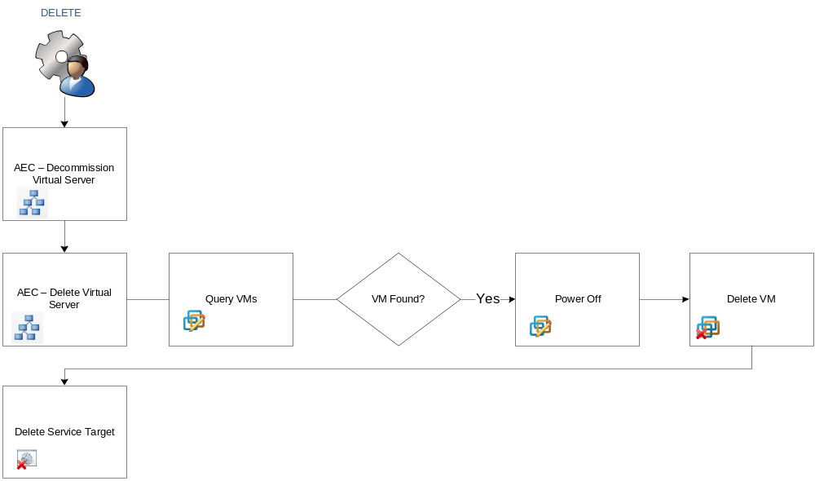Delete VM Process
The following processes occur during the delete server process:
- A query for VMs is executed.
- If the VM is found, it is powered off, and then deleted.
- The service target for the VM is deleted.
Example Usage:
Action | Required Values | Sample
DELETE | <action>  <vmName>  <company> | <![CDATA[  <vm>  <action>DELETE</action>  <vmName>DEV-MS100</vmName>  <company>Test</company>  </vm>  ]]>

Power On
When the VM_OPTS action is passed, and the POWERON subject is passed the following process occurs:
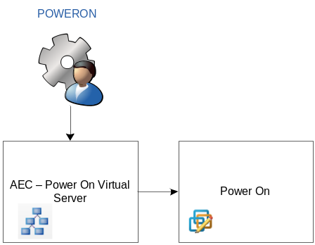

Power On Process

The following processes occur during the power on server process:
- The VM is powered on.
Example Usage:
Action | Subject | Required Values | Sample
VM_OPS | POWERON | <action>  <subject>  <vmName>  <company>  <osType> | <![CDATA[  <vm>  <action>VM_OPS</action>  <subject>POWERON</subject>  <vmName>DEV-MS100</vmName>  <company>Test</company>  </vm>  ]]>

Power Off - Soft
When the VM_OPTS action is passed, and the POWEROFFSOFT subject is passed the following process occurs:

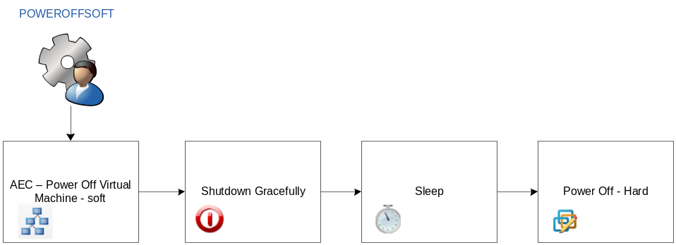

The following processes occur during the power off - soft server process:
- The VM is shut down gracefully using VMware Tools on the target operating system.
- A period of time passes.
- The VM is powered off (hard) if it is still running.
Example Usage:
Action | Subject | Required Values | Sample
VM_OPS | POWEROFFSOFT | <action>  <subject>  <vmName>  <company>  <osType> | <![CDATA[  <vm>  <action>VM_OPS</action>  <subject> POWEROFFSOFT </subject>  <vmName>DEV-MS100</vmName>  <company>Test</company>  </vm>  ]]>

Power Off - Hard
When the VM_OPTS action is passed, and the POWEROFFHARD subject is passed the following process occurs:

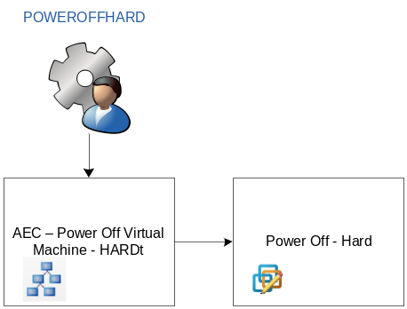

The following processes occur during the power off - soft server process:
- The VM is powered off (hard).
Example Usage:

Action | Subject | Required Values | Sample
VM_OPS | POWEROFFHARD | <action>  <subject>  <vmName>  <company>  <osType> | <![CDATA[  <vm>  <action>VM_OPS</action>  <subject> POWEROFFHARD </subject>  <vmName>DEV-MS100</vmName>  <company>Test</company>  </vm>  ]]>

Power Reset- Soft
When the VM_OPTS action is passed, and the POWERRESETSOFT subject is passed the following process occurs:

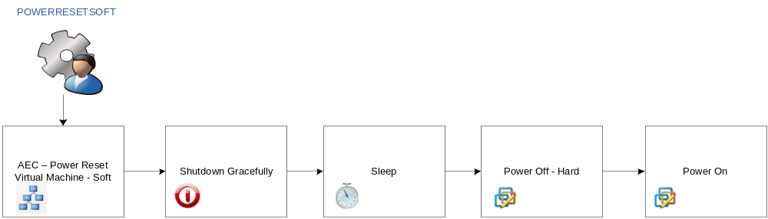

The following processes occur during the power off - soft server process:
- The VM is shut down gracefully using VMware Tools on the target operating system.
- A time of period passes.
- The VM is powered off (hard) if it is still running.
- The VM is powered on.
Example Usage:
Action | Subject | Required Values | Sample
VM_OPS | POWERRESETSOFT | <action>  <subject>  <vmName>  <company>  <osType> | <![CDATA[  <vm>  <action>VM_OPS</action>  <subject> POWERRESETSOFT </subject>  <vmName>DEV-MS100</vmName>  <company>Test</company>  </vm>  ]]>

Power Reset- Hard
When the VM_OPTS action is passed, and the POWERRESETHARD subject is passed the following process occurs:

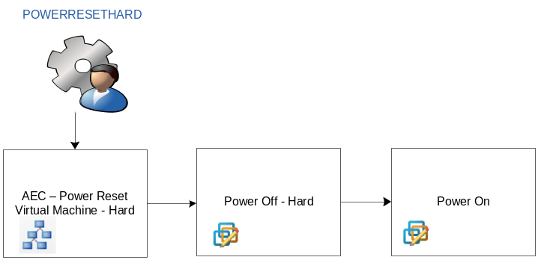

The following processes occur during the power off - soft server process:
- The VM is powered off (hard) .
- The VM is powered on.
Example Usage:
Action | Subject | Required Values | Sample
VM_OPS | POWERRESETHARD | <action>  <subject>  <vmName>  <company>  <osType> | <![CDATA[  <vm>  <action>VM_OPS</action>  <subject>> POWERRESETSOFT </subject>  <vmName>DEV-MS100</vmName>  <company>Test</company>  </vm>  ]]>

